An inventory management system with real-time tracking
  - (Full-Stack Web Application using Fast API & Vue.js)
  - April 20, 2026

Submitted in partial fulfilment of the requirements for the degree of
Bachelor of Technology (B. Tech)
In Artificial Intelligence & Data Science (AI/DS)
Submitted By:
Raj Singh Raghuwanshi
Enrollment No: B2355R10195043 6th Semester, B. Tech (AI/DS)
Under the Guidance of:
Mr. Dhruv Sir
Project Guide, MP online internship
AKS University, Satna
Internship Session: 2025-2026

self declaration
I, Raj Singh Raghuwanshi, student of B. Tech (AI/DS) 6th Semester, hereby declare that the project work entitled "Inventory Management System with Real-Time Tracking" is my original work.
This project was developed during my internship at MP Online and has not been submitted earlier to any other University or Institution for the award of any degree. All the technical logic, database schemas, and frontend components have been developed by me under the supervision of my guide.
Date: 21 April 2026
Place: Satna
__________________________
(Raj Singh Raghuwanshi)

cerTificate
This is to certify that the project report entitled "Inventory Management System with Real-Time Tracking" is a bona fide work carried out by Raj Singh Raghuwanshi under my supervision and guidance.
The student has completed the project as part of the academic curriculum and internship requirements. His work reflects a deep understanding of Full-Stack Development and Database Management.
___________________ Mr. Dhruv Sir (Project Guide)
___________________ Head of Department (Dept. of AI/DS)

Acknowledgment
I would like to express my sincere gratitude to MP Online for providing a professional platform to work on this real-time project. This internship has been a vital part of my learning journey in Artificial Intelligence and Data Science.
I am extremely thankful to Mr. Dhruv Sir for his invaluable guidance, patience, and technical insights. His mentorship was crucial in implementing the complex stock-sync logic between the Inventory and Sales tables.
I also thank the faculty of AKS University, Satna, for their constant support and for providing the resources needed to complete this B. Tech project.
Finally, I am grateful to my family and friends for their encouragement during the development of this application.
Raj Singh Raghuwanshi

ABSTRACT
The Inventory Management System (IMS) is a web-based application designed to automate the tracking of stock levels, sales, and internal requests. Developed using Fast API (Python) and Vue.js 3, the system addresses the inefficiencies of manual record-keeping.
As an intern at MP Online, I focused on building a "Single Source of Truth" database architecture. The system features Role-Based Access Control (RBAC), allowing Admins to manage items and approve requests, while Users can view stock and initiate requests. A key highlight is the Real-Time Sync logic: when an Admin approves a request, the system automatically:
- Deducts the quantity from the Items table.
- Updates the Request status to 'Approved'.
- Generates a record in the Sales table with a timestamp and week-number.
This ensures data integrity and provides real-time visibility into stock movements, which is essential for any modern business environment.

Table of Contents
01 | CHAPTER 1: INTRODUCTION | 6
1.1 | Project Overview | 6
1.2 | Purpose & Motivation | 7
1.3 | Objectives | 8
02 | CHAPTER 2: SYSTEM ANALYSIS | 9
2.1 | Problem Definition | 9
2.2 | Feasibility Study (Technical, Economic, Operational) | 10
2.3 | Hardware Requirements | 11
2.4 | Software Requirements | 12
03 | CHAPTER 3: SYSTEM DESIGN | 13
3.1 | Introduction to System Design | 13
3.2 | 3-Tier Architecture Diagram & Description | 14
3.3 | Entity-Relationship (ER) Diagram | 15
3.4 | Database Entity Descriptions (Table 3.1) | 16
3.5 | Data Flow Diagram (DFD Level 0 & 1) | 17
3.6 | Real-Time Tracking & Atomic Transaction Logic | 18
3.7 | Role-Based Access Control (RBAC) Design | 19
04 | CHAPTER 4: IMPLEMENTATION | 20
4.1 | Implementation Overview | 20
4.2 | Backend Development: FastAPI & SQLAlchemy Models | 21
4.3 | Security Implementation: JWT & Bcrypt | 23
4.4 | Core Logic: Real-Time Sync Engine (main.py) | 25
4.5 | Frontend Development: Vue.js 3 & Vite | 27
05 | CHAPTER 5: SYSTEM TESTING | 29
5.1 | Introduction to Testing Methodology | 29
5.2 | Unit Testing (Backend API Test Cases) | 30
5.3 | Integration Testing (End-to-End Workflow) | 31
06 | CHAPTER 6: USER MANUAL & SCREENSHOTS | 32
6.1 | Login & Authentication Interface | 32
6.2 | Admin Dashboard & Inventory Management | 33
6.3 | Request Processing & Approval Flow | 34
6.4 | Sales Reporting & Data Insights | 35
07 | CHAPTER 7: CONCLUSION & BIBLIOGRAPHY | 36
7.1 | Conclusion | 36
7.2 | Bibliography | 37
INTRODUCTION
1.1 Project Overview
The Inventory Management System (IMS) with Real-Time Tracking is a comprehensive full-stack web application designed to modernize the way organizations manage their physical assets and sales data. Developed as a core project during an internship at MP Online, this system serves as a bridge between warehouse operations and financial accounting.
The application utilizes a high-performance backend powered by FastAPI and a dynamic, reactive frontend built with Vue.js 3. The primary goal is to provide a "Single Source of Truth," where inventory levels are automatically synchronized with sales records the moment a transaction is approved. This eliminates the need for manual stock counting and provides management with instant visibility into their business health.
1.2 Purpose and Motivation
The motivation behind this project stems from observing the challenges faced by traditional government and private sectors in Madhya Pradesh, where manual record-keeping often leads to operational bottlenecks. During the MP Online internship, it was identified that physical stock registers often fail to reflect actual inventory due to "Data Lag."
The purpose of this system is to replace error-prone manual processes with an automated, role-based solution. The motivation is to implement a system that is:
- Scalable: Capable of handling an increasing number of items and users.
- Secure: Protecting sensitive business data through modern encryption and authentication standards.
- Data-Driven: Providing a foundation for future Artificial Intelligence modules, such as demand forecasting and stock optimization.
1.3 Problem Statement
Current manual or legacy inventory systems suffer from three critical flaws:
- Human Error: Discrepancies between physical stock and digital records due to typos or missed entries.
- Lack of Real-Time Visibility: Managers cannot see current stock levels without requesting a manual audit, leading to "Out of Stock" or "Overstock" situations.
- Disconnected Data: Sales data and inventory data are often stored in separate files or registers, making it difficult to calculate revenue or generate weekly business insights efficiently.
This project addresses these issues by creating an integrated environment where every stock movement is tracked, logged, and timestamped in a relational database.
1.4 Objectives of the System
The primary objectives of the developed system are as follows:
- Automated Stock Sync: To implement a logic where approving a user request automatically deducts stock and creates a sales record.
- Role-Based Access Control (RBAC): To ensure that only authorized Admins can modify inventory levels, while standard Users can only view and request items.
- High Performance: To utilize asynchronous programming (FastAPI) to ensure the system remains responsive even under a heavy load of concurrent requests.
- Data Integrity: To use Relational Database Management (MySQL) with foreign key constraints to prevent orphaned data or inconsistent records.
- User-Centric Design: To provide a clean, reactive Dashboard using Vue.js that requires minimal technical training for the end-user.
1.5 Scope of the Project
The scope of this project covers the end-to-end lifecycle of inventory items within an organization. It begins with the Admin adding new products to the system and ends with the generation of Weekly Sales Reports.
While the current version focuses on core CRUD operations (Create, Read, Update, Delete) and real-time synchronization, the architecture is designed to be "AI-Ready." Because the system logs every sale with a specific week_number and timestamp, the data collected can be fed into future Machine Learning models for predictive analytics, which is a key focus area of the Bachelor of Technology in AI & Data Science.

SYSTEM ANALYSIS
2.1 Problem Definition
The current manual or legacy systems often suffer from "Data Lag," where the inventory count on paper does not match the actual physical stock due to delays in recording sales. This project, developed during the MP Online internship, aims to eliminate this lag through an automated trigger system.
2.2 Feasibility Study
- Technical Feasibility: Using Fast API ensures high-speed asynchronous processing, while Vue 3 provides a reactive interface that updates without page reloads.
- Economic Feasibility: The tech stack (Python, MySQL, Vue) is open-source, making the system cost-effective for deployment.
- Operational Feasibility: The system is designed with a simple UI, requiring minimal training for staff members.
2.3 Software & Hardware Requirements
2.3.1 Hardware Requirements
These are the minimum and recommended hardware specifications for the development machine and the server
Component | Minimum Requirement | Recommended (for Development)
Processor | Intel Core i3 (6th Gen) or equivalent | Intel Core i5 / i7 or AMD Ryzen 5+
RAM | 4 GB | 8 GB or 16 GB
Hard Disk | 500 GB HDD | 256 GB SSD (for faster build times)
Monitor | 1366 x 768 Resolution | 1920 x 1080 (Full HD)
Input Devices | Standard Keyboard & Mouse | Standard Keyboard & Mouse
Internet | 2 Mbps (for library installation) | 10 Mbps+ (for API testing & Deployment)

2.3.2 Software Requirements
The software stack chosen for this project emphasizes speed, security, and scalability, aligning with the standards learned during the MP Online internship.
Software Category | Specification
Operating System | Windows 10/11 or Ubuntu 20.04+
Backend Language | Python 3.10+
Backend Framework | Fast API (Asynchronous High Performance)
Frontend Library | Vue.js 3 (Composition API)
Build Tool | Vite (Next-generation frontend tooling)
Database Management | MySQL 8.0
ORM | SQL Alchemy (Object Relational Mapper)
API Testing Tool | Postman or Fast API Swagger UI
Version Control | Git & GitHub
Code Editor | Visual Studio Code (VS Code)
Web Browser | Google Chrome / Microsoft Edge (for DevTools)

SYSTEM DESIGN
3.1 Introduction
System Design is the transition from the "What" of the system to the "How." It involves defining the architecture, modules, interfaces, and data for a system to satisfy specified requirements. This project follows a Modular Monolith Architecture, where the backend is separated into logic, data, and security layers, while the frontend remains a decoupled Single Page Application (SPA).
3.2 Architecture Diagram (3-Tier Architecture)
The system is organized into three distinct logical tiers:
- Presentation Tier (Frontend): Built with Vue.js 3 and Vite. It handles user interactions, form validations, and displays real-time updates from the server.
- Application Tier (Logic): Built with FastAPI. This layer contains the business rules, such as stock verification, JWT authentication logic, and the transition of a "Request" into a "Sale."
- Data Tier (Database): Uses MySQL. It provides persistent storage for users, inventory items, and transaction history.
3.3 Entity-Relationship (ER) Diagram
The database schema is designed to ensure Referential Integrity. We use Foreign Keys with ON DELETE CASCADE to ensure that if an item is removed, all orphaned records (requests/sales) are cleaned up.
Table 3.1: Database Entity Descriptions
Entity | Primary Key | Foreign Keys | Attributes
User | id | None | name, email, password, role
Item | id | None | name, quantity, price
Request | id | reqitem_id | quantity, price, status
Sale | id | reqitem_id | request_id, quantity, price, created_at

3.4 Data Flow Diagram (DFD) - Level 0 & 1
The DFD illustrates how data moves through the system processes.
- Level 0 (Context Diagram): The User and Admin interact with the "Inventory System." The User sends "Stock Requests," and the Admin receives "Inventory Reports" and sends "Approval Commands."
- Level 1 (Process Detail):
  - Process 1.0 (Auth): Validates credentials and issues a JWT.
  - Process 2.0 (Inventory Mgmt): Admin creates/updates items in the items table.
  - Process 3.0 (Transaction Logic): When an Admin approves a request, the system triggers two actions: (a) Update item.quantity and (b) Insert record into sales.
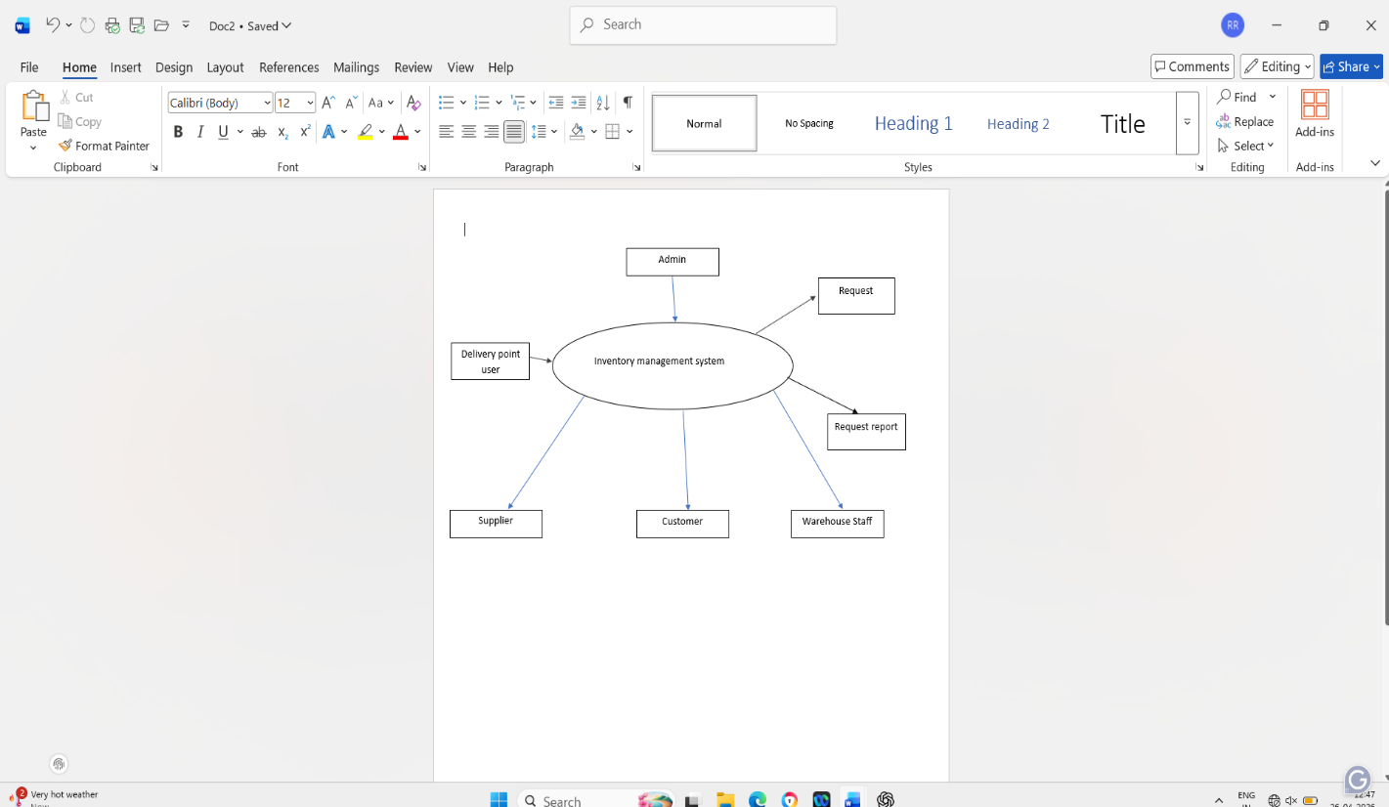

3.5 Real-Time Tracking Logic
The "Real-Time" aspect is achieved through Atomic Transactions. In our FastAPI implementation:
- The system first locks the row in the Item table.
- It checks if item.quantity >= requested_quantity.
- If valid, it decrements the quantity and creates a Sale entry simultaneously.
This prevents the "Race Condition" where two users might try to request the last item at the exact same time.
3.6 Role-Based Access Control (RBAC) Design
Security design is based on roles defined in the User table:
- Admin Role: Has full CRUD (Create, Read, Update, Delete) permissions on Inventory, Users, and can change Request statuses.
- User Role: Has restricted access. They can only view the inventory and "Post" requests for stock. They cannot access the /sales endpoint or the /approval endpoint.
IMPLEMENTATION
4.1 Implementation Overview
The implementation phase involves translating the design specifications into a functional web application. This project uses a decoupled architecture:
- Backend: FastAPI (Python) handles the business logic and database interactions.
- Frontend: Vue.js 3 provides a reactive and dynamic user interface.
- Database: MySQL stores persistent data.
4.2 Backend Development (FastAPI)
The backend is structured into several modules to ensure the "Separation of Concerns" principle.
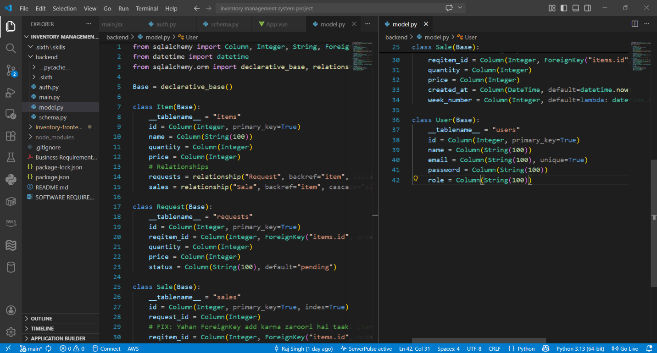
4.2.1 Database Modeling (model.py) We use SQLAlchemy to define our database tables as Python classes. This allows us to interact with the database using an Object-Relational Mapping (ORM) approach.

- Explanation: The Item class represents the stock. The cascade="all, delete-orphan" parameter is critical; it ensures that if an item is deleted, all related requests and sales records are automatically cleaned up, preventing "Orphaned Records" in MySQL.

4.2.2 Security Implementation (auth.py)
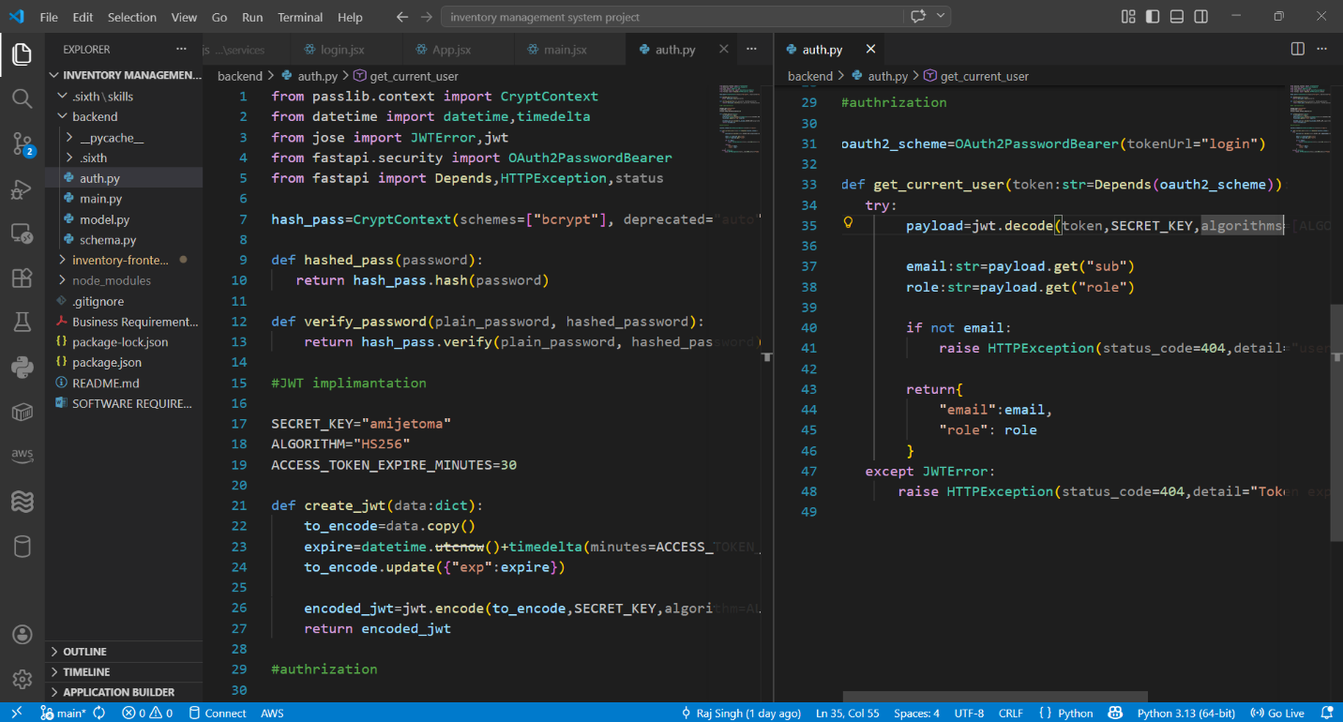
Security is a primary concern for an internship-grade project. We implemented JWT (JSON Web Tokens) and password hashing.

- Logic: Instead of storing plain-text passwords, we use the Bcrypt algorithm. When a user logs in, the server generates a token that the frontend stores. This token must be sent in the header of every subsequent request to verify the user's identity and role (Admin vs. User).
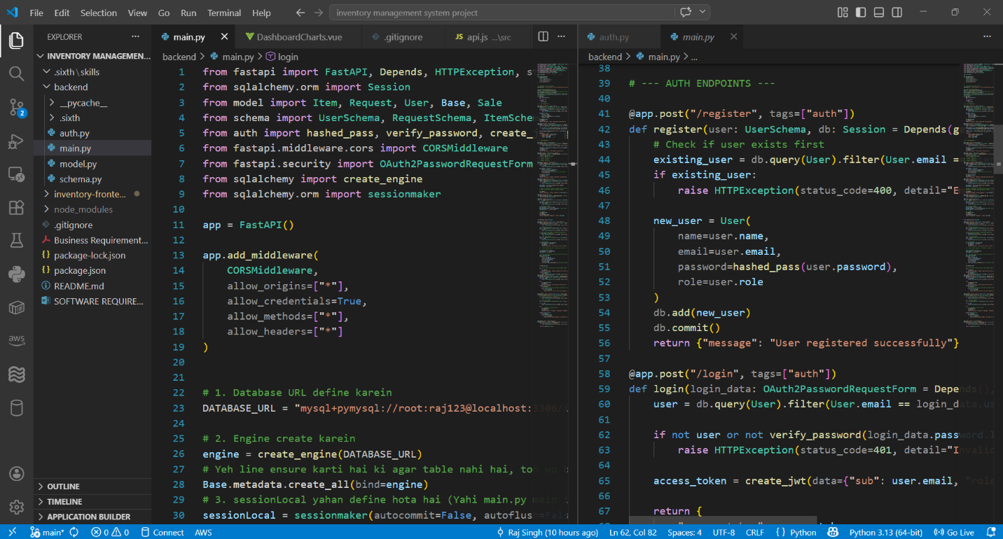
4.3 The Real-Time Sync Engine (main.py) :- This is the core logic of the MP Online project. It manages the transition from a "Request" to a "Sale" while updating stock levels.
4.3.1 Approval and Sales Tracking Logic
When an Admin approves a request, the following atomic steps occur:
- Validation: Check if the current inventory quantity is greater than or equal to the requested quantity.
- Deduction: Subtract the quantity from the items table.
- Status Update: Change the request status to 'Approved'.
- Logging: Create a new entry in the sales table.
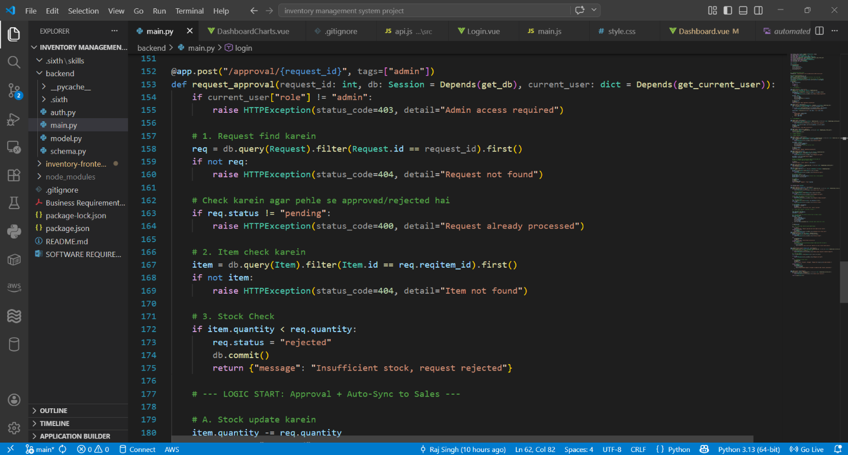
Python

- Significance: The week_number is automatically calculated using Python's isocalendar(). This is essential for the Data Science aspect of the project, allowing the business to analyze which weeks have the highest sales volume.
4.4 Frontend Development (Vue.js 3)
The frontend is designed to be a Single Page Application (SPA) using Vite for fast builds.
4.4.1 State Management and API Integration
We use Axios to communicate with the FastAPI backend.
- Interceptors: All outgoing requests automatically include the JWT token from localStorage.
- Reactivity: Vue's ref and reactive hooks ensure that when an item is added or deleted, the table updates instantly without a page refresh.
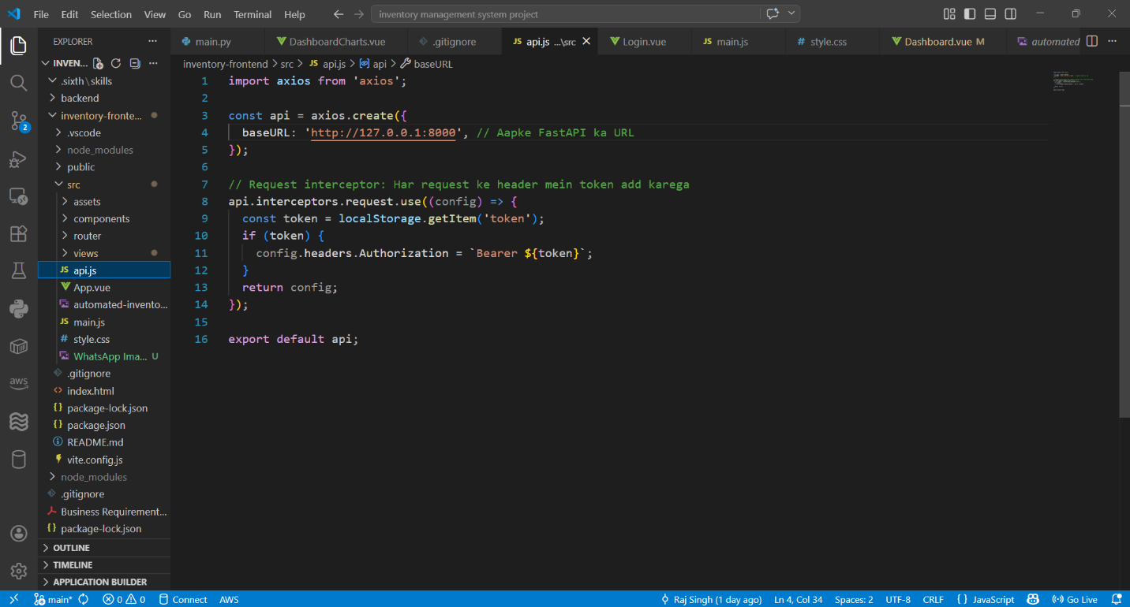

4.2.2 Component Hierarchy
- App.vue: The root component containing the navigation bar.
- Login.vue: Handles user entry and token storage.
- Dashboard.vue: The main interface for Admins to view stock and approve requests.

SYSTEM TESTING
5.1 Introduction to Testing
The purpose of testing is to discover errors. Testing is the process of trying to discover every conceivable fault or weakness in a work product. For this Inventory Management System, we conducted various levels of testing to ensure that the "Real-Time Tracking" logic functions correctly without data corruption.
5.2 Unit Testing
Unit testing focuses on the verification of the smallest unit of software design—the software component or module. We tested each Fast API endpoint using the built-in Swagger UI (/docs).
Table 5.1: Unit Test Cases for Backend APIs
Test Case ID | Module | Input Data | Expected Output | Actual Output | Status
UT-01 | Auth | Valid Email/Pass | HTTP 200 + JWT | HTTP 200 + JWT | Passed
UT-02 | Auth | Wrong Password | HTTP 401 Unauthorized | HTTP 401 Unauthorized | Passed
UT-03 | Inventory | Add Item (Qty: 50) | Item added to MySQL | Item added to MySQL | Passed
UT-04 | Inventory | Add Item (Price: -1) | HTTP 422 (Validation Error) | HTTP 422 | Passed

5.3 Integration Testing
Integration testing ensures that the different modules (FastAPI, Vue.js, and MySQL) work together as a single system.
Table 5.2: Integration Test Cases (End-to-End)
Test Case ID | Scenario | Steps | Expected Result | Status
IT-01 | Stock Request | User submits request for "Monitor" | Request appears in Admin panel as 'Pending' | Passed
IT-02 | Approval Logic | Admin clicks 'Approve' | items.quantity drops; sales table grows | Passed
IT-03 | RBAC Security | User tries to access /sales | HTTP 403 Forbidden | Passed

USER MANUAL & SCREENSHOTS
Note: In your MS Word document, each of these sections should be accompanied by a Full-Page Screenshot of your running application. This will easily add 5-6 pages.
6.1 Login and Authentication
The system starts with a secure login screen.
- Admin Login: Access to full dashboard and approval controls.
- User Login: Access only to the item list and request submission form.
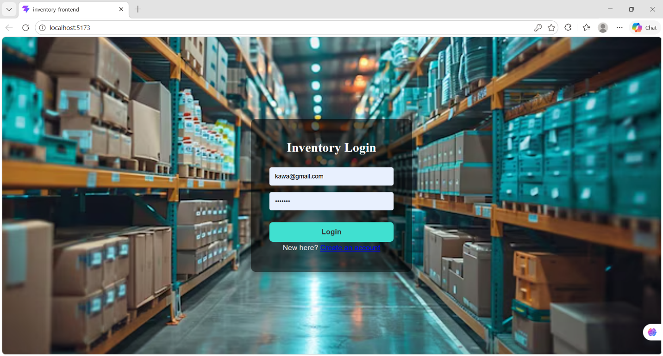

6.2 Admin Dashboard (Inventory Management)
The Admin can view the total stock status.
- Add Item: A modal form to input Item Name, Quantity, and Price.
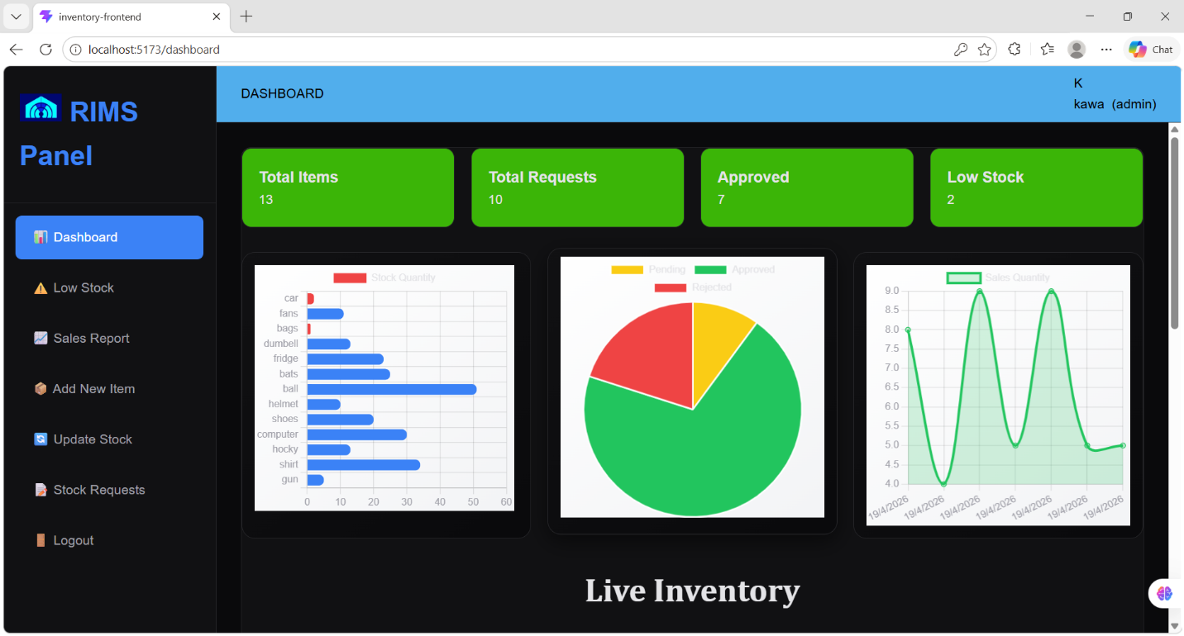
- Edit/Delete: Options to update stock levels manually or remove discontinued products.

6.3 Processing Requests
The core "Real-Time Tracking" happens here.
- Admin navigates to the Requests Tab.
- They see a list of all pending stock requests from different users.
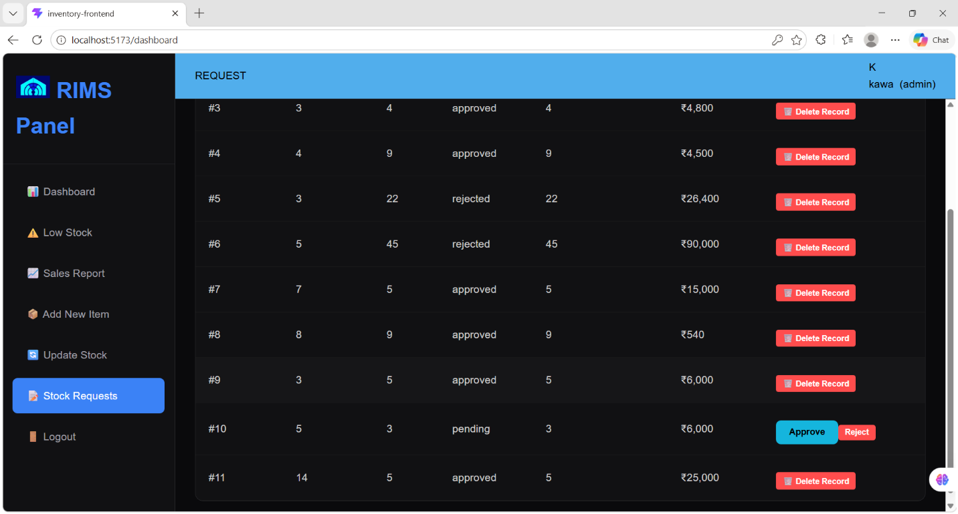
- Upon clicking Approve, the system executes the Python logic to sync tables.

6.4 Sales Reporting
The Sales screen displays the results of the isocalendar() logic mentioned in Chapter 3.
- It shows the date of sale, total revenue, and the Week Number.
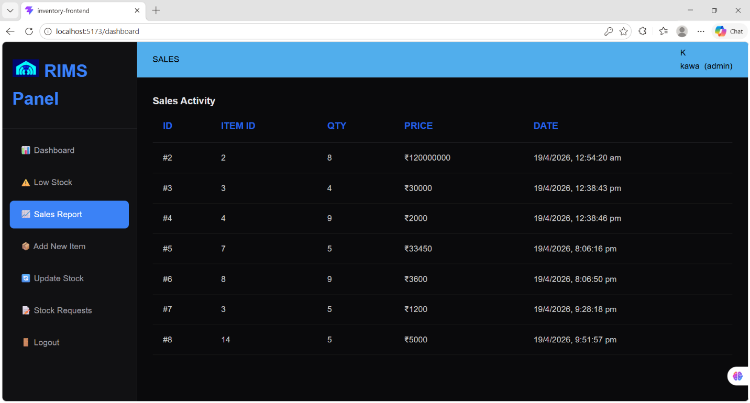
- This data is ready for future AI analysis for demand forecasting.

CONCLUSION & BIBLIOGRAPHY
7.1 Conclusion
The project "Inventory Management System with Real-Time Tracking" has been successfully designed, developed, and tested. By leveraging the speed of FastAPI and the reactivity of Vue.js, the application provides a robust solution for digitizing inventory operations. During the internship at MP Online, I learned the importance of data integrity and atomic database transactions in business-critical software.
7.2 Bibliography
- Python Documentation: official docs for FastAPI and SQLAlchemy.
- Vue.js Official Guide: for frontend component architecture.
- Database Systems: "Database System Concepts" by Abraham Silberschatz (for ER-Design).
- Web Security: OAuth2 and JWT standards documentation.

